Pneumobile Race coming in May
The pressure is increasing
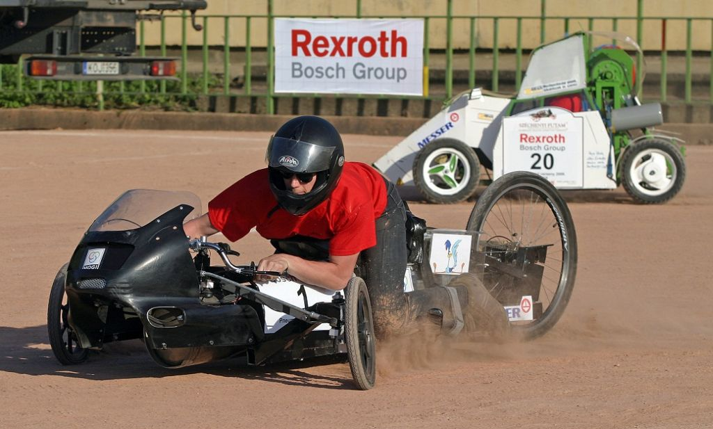

Tódor Kármán, the scientist considered the pioneer of missile technology and hypersonic astronautics, Salvador Dali, master of astonishment as well as Baron Münchhausen famous for his adventures were all born on 11 May . You are right to expect that the Pneumobile Race taking place on this day in Eger will hold many pleasant discoveries as well as creative and inspiring surprises for all the visitors. One thing is sure though: On the day of the race Eger will be swarming with large crowds of engineering students.
The visitors of the all-day-long festival of Rexroth companies on 11 May, Saturday in Eger's Érsekkert will experience an atmosphere bringing back the golden age of automobiles. The races will feature vehicles driven by compressed air in a great variety of shapes and designs with competitors racing for valuable prizes and, of course, the sympathy of the fans. The competitors will be introduced in the afternoon preceding the race between 16.30 and 17.45 on a grandiose parade in the city centre of Eger, on Eszterházy square.
41 teams from five countries with 94 participating university students, the most newcomers in the history of the race, will be standing at the starting line on Saturday in the sixth international Pneumobile Race of Bosch Rexroth companies. The teams will be contesting in several events with compressed air-driven vehicles designed and constructed by the contestants themselves.
On this all-day-long event the whole family will find something joyful and fun to do, since the fast-paced race will be supplemented with exciting programmes making this pleasant weekend in May truly memorable for everyone. There will be dance shows, fascinating physical experiments and drawing competitions. Following the race in the afternoon a wacky race featuring car racer Norbert Michelisz will take place. The non-stop enjoyment will be supplied by car daredevil Róbert Winkler.
For lovers of technical sports or youngsters and older folks just looking for fun: Érsekkert is the place to be!

Economical, precise, safe, and energy efficient: drive and control technology from Bosch Rexroth moves machines and systems of any size. The company bundles global application experience in the market segments of Mobile Applications, Machinery Applications and Engineering, Factory Automation, and Renewable Energies to develop innovative components as well as tailored system solutions and services. Bosch Rexroth offers its customers hydraulics, electric drives and controls, pneumatics, gear technology, and linear motion and assembly technology all from one source. With locations in over 80 countries, more than 37,500 associates generated sales revenue of approximately 6.5 billion euros in 2012.
To learn more, please visit www.boschrexroth.com
The Bosch Group is a leading global supplier of technology and services, active in the fields of automotive technology, energy and building technology, industrial technology, and consumer goods. According to preliminary figures, more than 306,000 associates generated sales of 52.3 billion euros in 2012. The Bosch Group comprises Robert Bosch GmbH and its more than 350 subsidiaries and regional companies in some 60 countries. If its sales and service partners are included, then Bosch is represented in roughly 150 countries. This worldwide development, manufacturing, and sales network is the foundation for further growth. Bosch spent some 4.5 billion euros for research and development in 2012, and applied for over 4,700 patents worldwide. The Bosch Group’s products and services are designed to fascinate, and to improve the quality of life by providing solutions which are both innovative and beneficial. In this way, the company offers technology worldwide that is “Invented for life.”
Additional information is available online at www.bosch.com and www.bosch-press.com

Reader Inquiries:
Tel.: +49 xxx xxx-xxxxx
Fax: +49 xxx xxx-xxxxx
E-Mail: xxxx@boschrexroth.de
Adresse: P.O. Box, D-PLZ Ort
Internet: www.boschrexroth.com

