|  |
| --- |
| <University, College name> <Name of the faculity> |
| Technical documentation |
| <Race number> |
| <Team name> |
| XII. International Aventics Pneumobile Competition 2019 – powered by Emerson |

|  |
| --- |
|  |

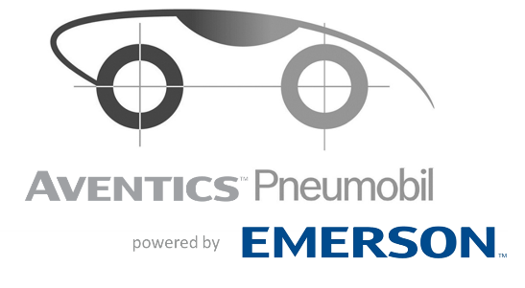

Content

1. Technical data sheet 3

2. Presentation of vehicle 5

3. Dimensions and weight 5

4. Frame and body 5

5. Driver safety 5

6. Compressed air Bottle 5

7. Puffer containers 5

8. Engine 5

9. Control system 5

10. Drive chain 5

11. Suspension /Wheel fixing 5

12. Steering system 5

13. Breaks 5

14. Appendix 5

# Technical data sheet





Undersigned teacher, from the University/College, as supporter teacher, declare that I have overlooked the sent documentation of planning vehicle and have controlled right the formal and content requirements of documents.

Additionally I certificate that the members of team have made the documents.

, 2018.

signature

# Presentation of vehicle

# Dimensions and weight

# Frame and body

# Driver safety

# Compressed air Bottle

# Puffer containers

# Engine

# Control system

# Drive chain

# Suspension /Wheel fixing

# Steering system

# Breaks

# Appendix